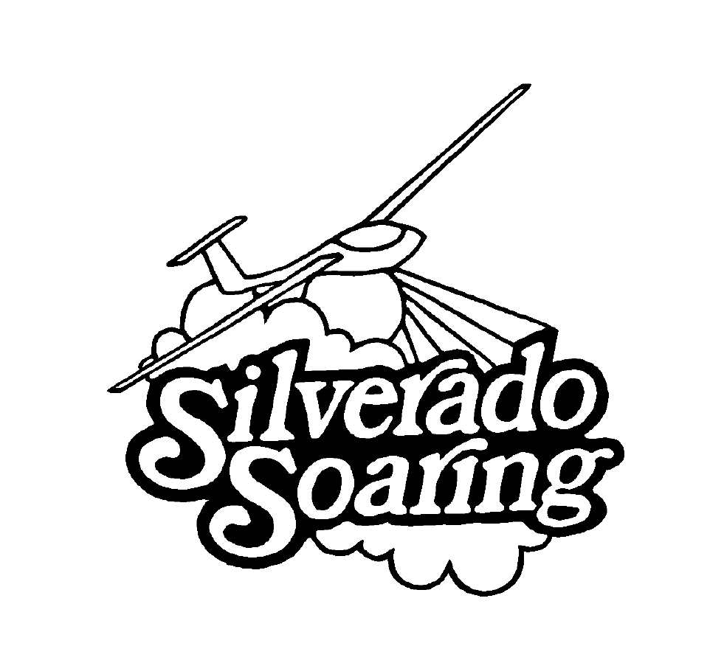

**APPLICATION FOR REGULAR MEMBERSHIP**

Name: DOB:

Address:

City: State: Zip:

Phones: Home Business Cell

Fax: E-Mail:

Employer: Occupation:

Member of other Flying Clubs?

FAA Certificate #: Date of Issue:

Aircraft owned or operated:

Licenses & Ratings:

Total Hours: Gliders Power All Categories

Any Aircraft Accidents? If “yes”, please explain on reverse or attach a separate sheet

SSA Membership #

***Presently the Initial fee is $250 (non-refundable) the Dues are 1 year in advance ($1200.) and after 1st. year can be paid monthly at $100. per month.***

*Before flying Club Aircraft, I agree to abide by the FAR’s, airport and FBO rules and procedures, as well as the rules, regulations and By-Laws of Silverado Soaring, Inc. I agree to join the Soaring Society of America (SSA) if I’m not already a member. I understand that, if accepted, I will fly Club Equipment at my own risk. Further, as a condition of membership, I freely and voluntarily agree to hold harmless Silverado Soaring, Inc., it’s officers and directors, members and former members from all injuries and damages which may result from any casualty or event which is connected to my membership in any manner.*

*I understand that Silverado Soaring, Inc. is a club and is operated by volunteers and that I may be called on from time to time to assist with Club business and equipment maintenance.*

*I understand that this application is subject to the consideration and approval of the Board of Directors and an Associate CFIG. Should I not be accepted, the initiation fee will be refunded.*

*I understand the above and affirm that the information concerning me is, to the best of my knowledge true and accurate.*

Signed: Date

When paid by Check or Bank Transfer Zelle: accounting@silveradosoaring.com and conditionally approved, Please send this application to: [ken@silveradosoaring.com](mailto:ken@silveradosoaring.com), or mail to: Silverado Soaring, Inc. PO Box 316 Genoa, NV 89411